Digital Logic Circuits 2

Digital Computers 2

What do you mean by the word digital? 2

What is bit? 2

What is a program? 2

Explain computer hardware. 2

What is computer organization? 2

What is computer design? 2

What is computer architecture? 2

Logic Gates 2

What are logic gates? 2

Boolean Algebra 3

What is a Boolean function? 3

What is a truth table? 3

What is a logic diagram? 3

What is the purpose of Boolean algebra? 3

Unit 1 from the syllabus covers unit 1, 2 and 4 from the book. Unit 2 covers unit 5. Unit 3 covers Unit 8.

# Digital Logic Circuits

## Digital Computers

### What do you mean by the word digital?

The word digital implies that the information in the computer is represented by variables that take a limited number of *discrete values*.

### What is bit?

Digital computers use the binary number system, which has two digits: 0 and 1. A binary digit is called a *bit.*

A computer system is sometimes subdivided into two functional entities: hardware and software.

The hardware consists of all the electronic components and electromechanical devices that comprise the physical entity of the device.

The software consists of the instructions and data that the computer manipulates to perform various data-processing tasks.

### What is a program?

A sequence of instructions for the computer is called a *program.* The data that are manipulated by the program constitute the *data base*.

### Explain computer hardware.

The hardware of the computer is usually divided into three major parts.

The CPU contains an arithmetic and logic unit for manipulating data, several registers for storing data, and control circuits for fetching and executing instructions.

The memory of a computer contains storage for instructions and data. It is called a RAM because the CPU can access any location in memory at random and retrieve the binary information within a fixed interval of time.

The input-output processor (IOP) contains electronic circuits for communicating and controlling the transfer of information between the computer and the user.

### What is computer organization?

*Computer organization* is concerned with the way the hardware components operate and the way they are connected to form the computer system.

### What is computer design?

*Computer design* is concerned with the hardware design of the computer. It is concerned with the determination of what hardware should be used and how the parts should be connected. This aspect of computer hardware is sometimes referred to as *computer implementation.*

### What is computer architecture?

Computer organization is concerned with the structure and behaviour of the computer as seen by the user. It includes the information formats, the instruction set, and techniques for addressing memory.

## Logic Gates

Binary information is represented by physical quantities called *signals.* Signals exist throughout the computer in one of two recognizable states. The two states represent a binary variable that can be 1 or 0.

Binary logic deals with binary variables and with operations that assume a logical meaning.

### What are logic gates?

The manipulation of binary information is done by logic circuits called *gates.*

Gates are blocks of hardware that produce signals of binary 1 or 0 when input logic requirements are satisfied.

Each gate has a distinct graphic symbol, and its operation can be described by means of an algebraic expression.

The I/O relationship of the binary variables for each gate can be represented in a tabular form by a truth table.

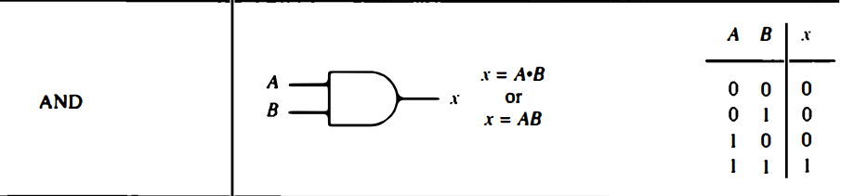 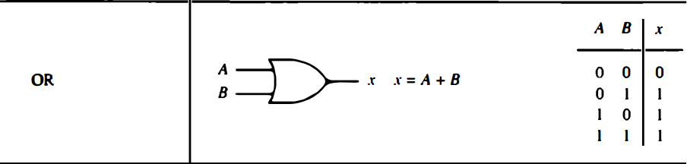 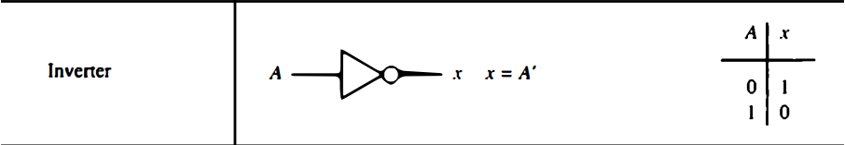 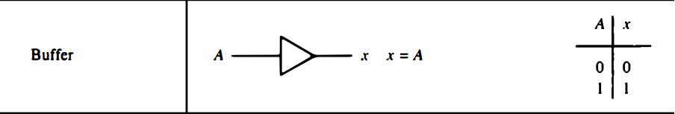 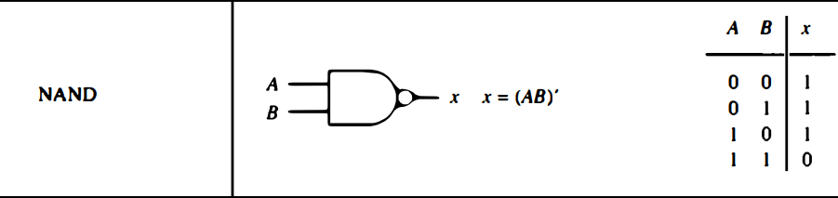 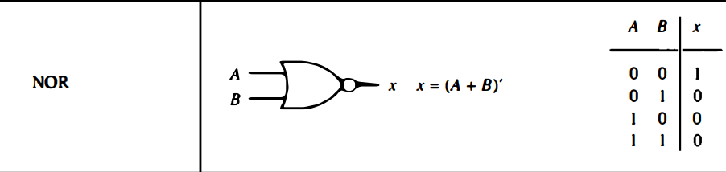

## Boolean Algebra

Boolean algebra is an algebra that deals with binary variables and logic operations.

### What is a Boolean function?

A Boolean function can be expressed algebraically with binary variables, the logic operation symbols, parentheses, and equal sign.

### What is a truth table?

The relationship between a function and its binary variables can be represented in a truth table. To represent a function in a truth table we need a list of 2n combinations of the *n* binary variables.

### What is a logic diagram?

A Boolean function can be transformed from an algebraic expression into a logic diagram composed of AND, OR, and inverter gates.

### What is the purpose of Boolean algebra?

The purpose of Boolean algebra is to facilitate the analysis and design of digital circuits. It provides a convenient tool to:

1. Express in algebraic form a truth table relationship between binary variables.
2. Express in algebraic form the input-output relationship of logic diagrams.
3. Find simple circuits for the same function.